Otajanov Ziyodillo
Research Paper
Field of Study: Economics
Academic Year: 2025–2026

REMOTE WORK AND ITS
ORGANIZATIONAL CONSEQUENCES

A Study Based on Uzbekistan:
Productivity, Organizational Culture, Employee Wellbeing, and Future Work Models
2026

ABSTRACT
Remote work has gradually — and then all at once — changed the way organizations around the world manage people, coordinate effort, and sustain culture. Uzbekistan came to this shift somewhat later than Western economies, but it has caught up fast. The country's IT Park ecosystem grew from a small cluster of companies in 2019 to more than 2,000 residents by 2024. ICT service exports nearly doubled in a single year, climbing from around $270 million in 2022 to $440 million in 2023. And the government has staked out an ambitious destination: $5 billion in IT exports by 2030. Getting there means distributed and hybrid work can't just be tolerated — it has to be done well.
This study is built on secondary research: publicly available reports from UNDP, the OECD, and Gallup; official data from IT Park Uzbekistan and the Ministry of Digital Technologies; peer-reviewed academic literature; and credible business journalism. The analysis looks at four organizational outcomes — productivity, culture, employee wellbeing, and management effectiveness — and uses the Job Demands–Resources (JD-R) framework as its main conceptual tool for making sense of the wellbeing findings.
What the evidence shows is that Uzbekistan's remote work story is really two stories happening side by side. The first belongs to the fast-growing IT and freelance sector, where distributed work has driven productivity gains, opened new earnings pathways for young talent outside Tashkent, and generated real foreign exchange. The second belongs to the traditional domestic economy — banking, government administration, healthcare, education, manufacturing — where remote adoption has stayed around 8–10%, and where cultural habits, crowded household conditions, and underdeveloped management remain serious obstacles. Hybrid arrangements, this study argues, offer the most workable path forward: they keep the in-person relational depth that local workplace culture genuinely needs, while still capturing the real benefits that flexibility provides.
Keywords: remote work, hybrid work, Uzbekistan, IT Park, digital economy, productivity, organizational culture, employee wellbeing, Job Demands–Resources model

INTRODUCTION
The way Uzbeks work has changed more over the last five years than in the two decades before that. Reliable internet, near-universal smartphone access, and a young workforce that's grown up comfortable with digital tools have moved a meaningful slice of professional life out of the traditional office. Tasks that once required physical presence — designing a logo for a foreign client, building software for a startup in Berlin, translating legal documents for a London firm — now get done from apartments in Tashkent, cafés in Samarkand, and family homes in Andijan.
The COVID-19 pandemic then compressed what might have taken years into a matter of weeks. State agencies, private companies, and universities that had long resisted distributed work were forced to adapt almost overnight. Globally, remote work adoption jumped from around 17% of the workforce in 2019 to 44% at the 2020 peak. Uzbekistan was part of this shift, but the experience was uneven. The IT sector embraced distributed work with genuine enthusiasm; many traditional employers treated remote arrangements as a temporary inconvenience to be reversed as quickly as possible.

The Uzbek Context
Uzbekistan's engagement with remote work has developed against a deliberately supportive policy backdrop. The 'Digital Uzbekistan – 2030' strategy positioned the digital economy as a national strategic priority, and IT Park Uzbekistan was set up to anchor that ambition in practice. According to UNDP (2025), the information and communications sector employed 87,800 people in 2023 — a 65.4% increase from 2010 — making it one of the fastest-growing parts of the country's labour market. ICT exports nearly doubled in a single year, reaching $440 million in 2023, with IT Park residents alone accounting for $344 million of that figure.
A substantial portion of this growth rests directly on remote work. Uzbek developers, designers, translators, and analysts are increasingly serving clients in North America, Europe, and the Gulf without ever boarding a plane. Government programmes like 'One Million Uzbek Programmers' have widened the talent pipeline. By 2025, the IT Park resident count had crossed 2,000, and regional IT Parks had opened in Bukhara, Samarkand, and Namangan.
The situation in traditional sectors is quite different. Banking, government offices, healthcare, education, and manufacturing remain largely office-based. Cultural factors slow the transition: Uzbek workplace culture places real value on face-to-face contact, hierarchical mentoring relationships, and shared rituals around meals, welcomes, and collective milestones. Add to that the household realities many workers face — multigenerational homes with limited private space and significant family obligations — and the barriers to sustained remote work become concrete.

Research Questions
This study addresses four questions at the intersection of organizational management and national economic strategy:
• How does remote work actually affect productivity and job satisfaction among Uzbek employees?
• What organizational risks come with sustained remote and hybrid arrangements in Uzbek workplaces?
• How do fully remote, hybrid, and fully on-site models compare in terms of productivity and culture in the Uzbek context?
• Can hybrid arrangements moderate the drawbacks typically associated with full-time remote work?

Why This Matters Now
These questions carry particular weight in 2026. Globally, the pendulum is swinging: many large employers are issuing return-to-office mandates while employees increasingly treat flexibility as a non-negotiable. For Uzbekistan, the stakes are higher still. The government's $5 billion IT export target for 2030 cannot be reached without a mature, competently managed remote work ecosystem. Figuring out what works — and what doesn't — is therefore not just an academic question. It's a live issue of national economic strategy.
LITERATURE REVIEW

International Evidence
Mutebi and Hobbs (2022) examined remote and hybrid working in the United Kingdom using three large national datasets. Remote work peaked at roughly half the workforce during the first lockdown and settled at around 22% by September 2022. Most workers reported improved wellbeing and a better work–life balance, but the study also found elevated stress, eroded personal boundaries, and noticeably weaker promotion prospects for full-time remote workers — with a visible socioeconomic divide in who actually captured the gains.
Fang, Gunderson, Hartley, King, and Ming (2025) surveyed 805 employers across Atlantic Canada. Remote work rose from 5.6% pre-pandemic to a peak of 21.9%, eventually settling at around 8.5%. Higher levels of remote work correlated with stronger reported productivity and innovation — but 39% of employers said managing remote workers had become noticeably more complicated than managing on-site staff. That's not a trivial fraction.
Pabilonia and Redmond (2024), researchers at the U.S. Bureau of Labor Statistics, analysed 61 private-sector industries between 2019 and 2021. The industries that shifted most toward remote work also recorded the fastest growth in total factor productivity — even after controlling for pre-existing industry trends. This is meaningful: it suggests remote work may be actively driving productivity gains rather than simply correlating with them.
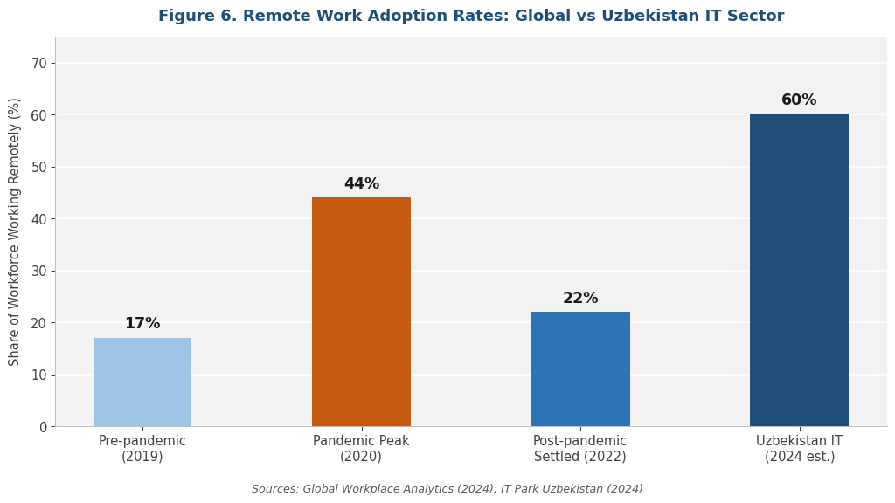
Dong, Tan, Zhang, Sun, and Huang (2025) examined 343 Chinese workers through the Job Demands–Resources (JD-R) lens. Remote work affected wellbeing through two competing pathways simultaneously: family–work conflict reduced wellbeing, while increased job engagement improved it. Workers who were better at managing the boundary between work and home captured most of the upside.
Williamson (2022) offered a comprehensive Irish perspective. An impressive 95% of remote workers surveyed wanted to continue working remotely at least part of the time; 81% of firms planned to keep remote arrangements. Productivity gains of up to 22% were recorded where conditions were genuinely supportive, and the average remote worker saved around €413 in costs and 93 commuting hours per year — figures that tend to shift people's views about what working from home is actually worth.

Uzbek and Regional Sources
UNDP (2025), in its Digital Economy of Uzbekistan report, documents the structural shift in the country's labour market: ICT employment grew 65.4% between 2010 and 2023, reaching 87,800 workers. The report also notes that Uzbekistan still trails regional peers in ICT employment share — indicating meaningful room to grow further.
OECD (2025), in its Roadmap for Sustainable Investment Policy Reforms in Uzbekistan, identifies IT Park Uzbekistan as the central engine of the country's digital transformation. Key 2024 indicators include rapid resident growth, expanded export volumes, and rising foreign direct investment — much of it tied directly to remote and outsourced business models.
IT Park Uzbekistan (2024) reports that resident numbers exceeded 2,000 by 2024, with ICT exports from IT Park alone reaching $344 million out of a $440 million national total. Over 100,000 specialists have been trained through programmes associated with the Park — numbers that speak to something more than a niche sector.
Web of Journals (2024), reviewing remote work trends inside Uzbekistan, identifies several locally specific constraints: uneven internet quality outside major urban centres, a managerial culture still rooted in physical oversight, regulations that haven't fully caught up with distributed work, and household environments that frequently lack dedicated workspace.
Gallup (2026), providing Uzbekistan-level data in its State of the Global Workplace report, shows that employee engagement in Uzbekistan trails global averages. Whatever the work model, management practices need investment.
Taken together, these sources paint a picture that is genuinely bimodal: an export-driven IT sector that thrives on distributed work, and a traditional domestic sector where adoption remains slow and cultural barriers remain real.
METHODOLOGY

Research Design
This study uses a systematic secondary research design. No primary data — surveys, interviews, experiments — were collected. Instead, the analysis aggregates findings from peer-reviewed academic literature, reports from international organizations, official Uzbek government and industry data, and credible business journalism. This approach suits the current moment: a substantial body of empirical work has accumulated since 2020, and synthesizing across sources reveals patterns that no single study could surface on its own.

Source Selection
Sources were included where they met at least one of the following criteria:
• Published by an international organization with established methodology (UNDP, OECD, Gallup, World Bank, ILO)
• Issued by official Uzbek government or industry bodies (IT Park Uzbekistan, Ministry of Digital Technologies, Statistics Agency)
• Peer-reviewed academic articles indexed in recognized academic databases
• Reports from credible specialist research organizations (Global Workplace Analytics, Great Place To Work, Buffer, Chanty)
• Business journalism from outlets with editorial review (CNN Business, Forbes)
Sources were excluded if they relied on anonymous authorship, failed to disclose their methodology, or could not be cross-verified against at least one other independent source.

Research Variables
The study examines four central outcome variables: productivity (self-reported performance, total factor productivity indicators, and output-based assessments); organizational culture (morale, belonging, communication quality, leadership effectiveness); employee wellbeing (work–life balance, job satisfaction, burnout, psychological stress); and management effectiveness (employer-reported challenges, trust levels, and use of oversight tools).
These variables aren't treated in isolation. A central concern throughout is how they interact — for example, how individual productivity gains can coexist with weakening organizational culture, or how flexibility benefits get undermined by burnout when work–life boundaries blur.

Data Sources Overview

Source | Focus / Data Type | Year
UNDP — Digital Economy of Uzbekistan | ICT employment, sector growth | 2025
OECD — Investment Policy Roadmap, Uzbekistan | IT Park indicators, investment trends | 2025
IT Park Uzbekistan (official data) | Resident count, exports, employment | 2024
Gallup — State of the Global Workplace: Uzbekistan | Engagement, wellbeing indicators | 2026
Web of Journals — Remote Work in Uzbekistan | Local trends, constraints, barriers | 2024
CNN Business — Uzbekistan IT hub feature | Outsourcing growth, sector profile | 2025
Mutebi & Hobbs | UK remote work outcomes study | 2022
Fang, Gunderson et al. | Atlantic Canada employer survey (n=805) | 2025
Pabilonia & Redmond (US BLS) | Total factor productivity, 61 industries | 2024
Dong, Tan, Zhang et al. | JD-R model, Chinese remote workers | 2025
Williamson | Irish cost–benefit analysis of remote work | 2022
Global Workplace Analytics | Productivity benchmarks, error rates | 2024
Buffer — State of Remote Work | Worker preferences, burnout data | 2023
Table 1. Summary of Primary Data Sources

Analytical Framework
The study applies a comparative framework at three levels: the individual worker, the organization, and cross-contextual comparison across national settings and work models. The Job Demands–Resources (JD-R) model is the conceptual lens for interpreting wellbeing outcomes. It distinguishes between the demands remote work places on employees — family–work conflict, isolation, blurred personal boundaries — and the resources it provides: autonomy, flexibility, reduced commuting, and wider earning opportunities. This distinction proves especially useful for understanding why outcomes vary so widely across Uzbek workers, whose household conditions and managerial environments differ substantially.

Limitations
Three limitations deserve honest acknowledgement. First, the secondary research design means the analysis is only as strong as its underlying sources. Some Uzbekistan-specific statistics come from industry self-reports — particularly IT Park — and haven't been independently audited. Second, much of the international literature is concentrated in North America and Western Europe, which limits how directly it transfers to Uzbekistan's cultural and household context; Uzbek-specific sources were prioritised wherever available. Third, the field has moved fast: findings from 2020–2021 may overstate effects that have since moderated, so 2023–2026 sources carry more weight throughout this analysis.
RESULTS

Productivity Outcomes
The evidence on productivity points consistently upward — but the conditions matter enormously. Under genuinely favourable circumstances, international benchmarks show remote workers outperforming office-based peers by 35–40% and making 40% fewer errors. Macroeconomic data from 61 U.S. industries show that those with the largest shifts to remote work also recorded the fastest total factor productivity growth. In Ireland, productivity gains of up to 22% were observed where workers had proper support (Williamson, 2022).
In Uzbekistan, productivity evidence is concentrated in the export-oriented IT sector — which makes sense, because measurable outputs and international client deadlines make remote work naturally compatible with strong performance. The near-doubling of ICT exports from $270 million in 2022 to $440 million in 2023 is itself a powerful indirect indicator: the same workforce produced substantially more billable output through distributed channels.
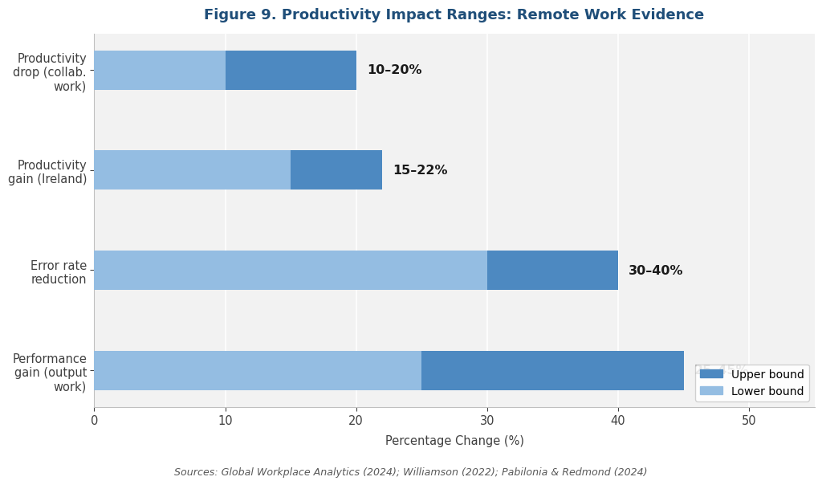
That said, the picture isn't uniformly positive. Stanford-based research found that fully remote workers' productivity drops by 10–20% in roles that depend heavily on in-person collaboration. This sectoral split — where output-defined knowledge work gains and collaborative, iterative roles lose — maps directly onto Uzbekistan's experience. The contrast between thriving IT freelancers and traditional managers struggling to oversee remote teams illustrates the pattern precisely.

Organizational Culture
Culture is the outcome domain that generates the most consistent concern across the literature. Globally, 65% of companies report difficulty maintaining morale in remote or hybrid settings. In Uzbekistan, this challenge is amplified by cultural specifics that are worth naming directly.
Uzbek workplace culture places real value on face-to-face interaction, shared meals, collective rituals around welcomes and farewells, and hierarchical mentoring relationships through which organizational identity and tacit knowledge have traditionally passed. Video calls struggle to replicate these functions. The Web of Journals (2024) review notes that Uzbek managers frequently express genuine discomfort with leading teams they can't directly observe — and that newer employees in particular suffer from losing the informal mentoring that physical presence naturally provides. Gallup's (2026) Uzbekistan country-level data reinforces this: engagement levels trail global averages, which means culture and cohesion require deliberate, sustained investment when workforces are dispersed.

Key finding: Organizational culture is the dimension where remote work pays its real cost in Uzbekistan. Unlike productivity — which becomes visible within weeks — culture erodes over months and surfaces in lagging indicators: higher turnover, slower onboarding, weaker internal mobility, and declining engagement scores.

Employee Wellbeing
Wellbeing findings are genuinely mixed, and they depend heavily on individual circumstances — a pattern the JD-R framework predicts and local evidence confirms. On the upside, most remote workers globally report better work–life balance, less commuting stress, and greater personal autonomy. Buffer (2023) found that 98% of remote workers worldwide would prefer to continue working remotely for the rest of their careers. That's a striking figure. It reflects how strongly flexibility is valued once people have actually experienced it.
On the other side, 70% of remote employees report challenges with work–life balance. Mutebi and Hobbs (2022) documented heightened stress and boundary erosion. Dong et al. (2025) found that family–work conflict actively reduces wellbeing, particularly for workers with limited ability to manage competing demands.
In Uzbekistan, this last point carries particular weight. Many Uzbek households are multigenerational, with limited dedicated workspace and significant family responsibilities — childcare, elder care, hosting guests on short notice. Workers without a quiet, private workstation face elevated family–work conflict. The JD-R framework predicts, and Uzbek field evidence supports, that wellbeing outcomes split sharply: workers with strong personal resources tend to thrive remotely; those without consistently struggle.
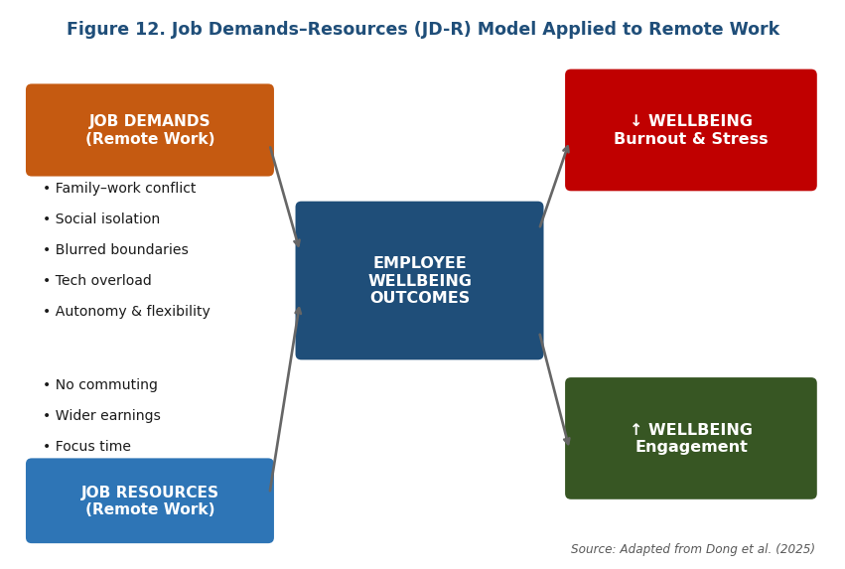

Management Effectiveness
Management complexity stands out as the principal operational challenge, both globally and locally. Fang et al. (2025) found that 39% of Atlantic Canadian employers described managing remote workers as significantly more complicated than managing on-site staff. Chanty (2025) reported that 85% of leaders experience what researchers are calling 'productivity paranoia' — a persistent difficulty trusting that remote workers are productive without the ability to directly observe them.
In Uzbekistan, where managerial culture has traditionally relied on physical oversight (known locally as 'koʼrib turish' — roughly, 'seeing with one's own eyes') and hierarchical visibility, this challenge is amplified considerably. The Web of Journals (2024) analysis is clear that managerial skill development — not technology, internet access, or employee willingness — is the binding constraint on broader remote work adoption in Uzbek organizations.

Worker Preferences
Worker preferences in Uzbekistan broadly mirror global patterns. The rapid proliferation of Uzbek profiles on platforms like Upwork, Fiverr, and Toptal — including in regional cities like Bukhara, Samarkand, and Namangan — signals strong and genuine preference for flexible, remote-first arrangements among younger workers. The 98% global preference figure from Buffer (2023) is consistent with the real choices Uzbek IT workers are making with their careers.

DISCUSSION
The findings invite four broader observations about what the evidence actually means for Uzbekistan.

The Productivity Question Is Largely Settled — But Only For Certain Roles
For practical purposes, the productivity debate in Uzbekistan is resolved — but only for certain types of work. The IT export numbers settle the question for output-defined knowledge work: distributed teams deliver. What the headline figures obscure is that this success hasn't transferred cleanly to roles built on tacit knowledge, dense collaboration, and iterative problem-solving. Banking branches, government offices, manufacturing supervisors, and classroom teachers can't simply be moved online without meaningful loss. Blanket policies — whether fully remote or fully on-site — will underperform in one direction or the other.
The organizational lesson isn't 'remote works' or 'remote doesn't work.' It's that the answer genuinely depends on the role, and organizations need to be honest with themselves about which roles are which.

Culture Is Where Remote Work Pays Its Real Cost
Culture is where remote work extracts its real price in Uzbekistan — and that price is likely higher here than in many Western settings. Unlike productivity, which shows up quickly, culture erodes slowly and appears in lagging indicators: turnover climbs, internal mobility weakens, onboarding slows, engagement drops. The 65% global figure for culture struggles is likely an understatement for Uzbek organizations, where in-person relational depth is more central to organizational identity than in many of the contexts where that research was conducted.
Organizations that treat culture as a residual — something that will sort itself out on the side — will accumulate organizational debt that eventually shows up in the numbers. It always does.

Wellbeing Is Really a Question of Household Resources
Employee wellbeing in Uzbekistan is determined less by the work model itself than by the household conditions surrounding each individual worker. The JD-R framework predicts this, and local conditions confirm it. Workers with private workspaces, supportive family environments, and genuinely enforced personal boundaries can thrive remotely. Workers without these resources consistently struggle — not because of the work model, but because of the conditions around it.
Effective policy, then, lies less in mandating a work model from the top and more in giving workers genuine choice: backed by employer investment in home-office equipment subsidies, mental health support, and 'right to disconnect' norms that are actually enforced rather than just printed in a policy document.

Hybrid Is the Most Defensible Model for Uzbekistan
Hybrid arrangements offer the most defensible path forward for Uzbek organizations. They capture most of the productivity benefits of remote work while preserving the in-person relational depth that Uzbek managerial culture genuinely values and, in many cases, genuinely needs.
In practice, a two-to-three days in office, two-to-three days at home split tends to deliver the cleanest balance. Focused individual work happens at home, where interruptions are fewer. Collaborative work, onboarding conversations, performance reviews, and team rituals happen in person, where trust and tacit knowledge flow more naturally.
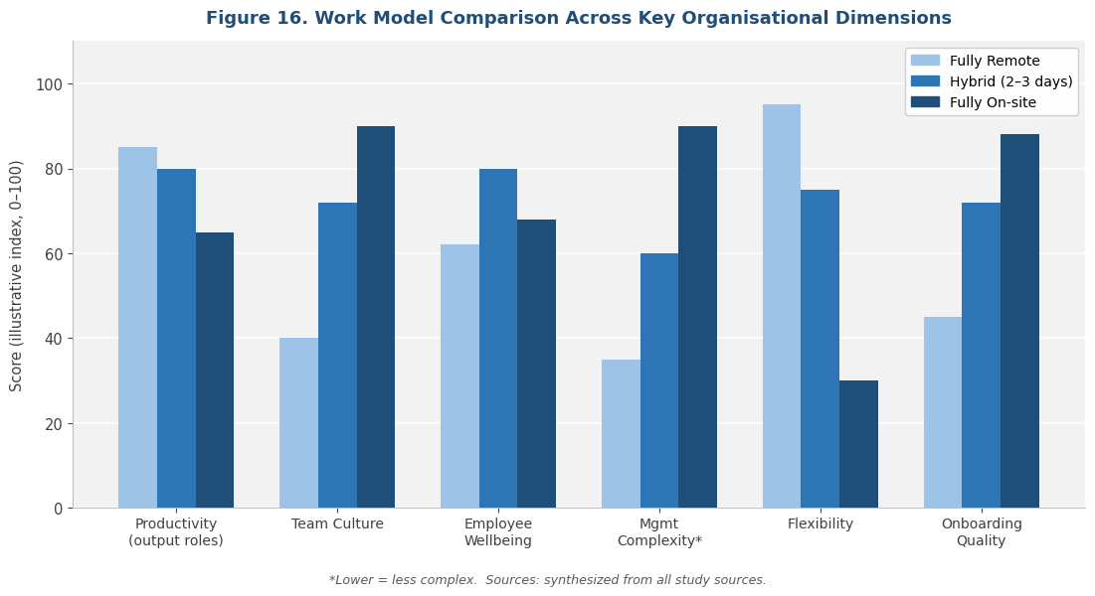
The harder question is implementation. Hybrid arrangements actually demand more managerial skill than either pure model — not less. They require explicit decisions about anchor days, meeting structures that don't relegate remote participants to second-class status, onboarding processes that function across dispersed teams, and performance evaluation methods that don't inadvertently reward visibility over output. Uzbek organizations that treat hybrid as a deliberate design challenge will outperform those that treat it as a casual compromise.

The 2026–2027 return-to-office wave often signals not that remote work failed on its merits, but that the managerial infrastructure needed to make it succeed was never built. For Uzbekistan, where managerial capacity is itself a developing resource, the implication is pointed: the country cannot reach its $5 billion IT export target by 2030 without building a generation of managers who can lead distributed teams competently.

The Regional Equalization Effect Deserves More Attention
One dimension of Uzbekistan's remote work expansion that the international literature almost entirely ignores is its regional equalization effect. Remote work here functions not just as a personal productivity arrangement but as a genuine route out of underemployment for young people in Bukhara, Nukus, Andijan, and Fergana — cities where local labour markets can't absorb their skills — who can now earn in dollars and euros without relocating to Tashkent or emigrating entirely. This effect is potentially one of the most economically significant, and least studied, consequences of the country's digital transformation. It deserves serious attention from both researchers and policymakers.

CONCLUSION
Remote work is no longer an experiment in Uzbekistan. It has become a structural feature of the country's economy — particularly in its rapidly expanding IT export sector — and the evidence assembled in this study suggests it is, on balance, a net positive for productivity, worker preferences, and national export performance. It also imposes real costs on organizational culture, management complexity, and equitable access to its benefits. Both things are true simultaneously.
Four conclusions emerge with reasonable confidence from the evidence:

Finding | Summary
Productivity | Gains are real but strictly role-dependent. Knowledge work with clear, measurable outputs benefits substantially. Collaboration-heavy and tacit-knowledge-heavy roles lose. Blanket policies fail in both directions.
Culture | The principal casualty of remote work. Without deliberate, sustained investment, organizational cohesion weakens slowly and surfaces in lagging indicators. The cultural cost is likely higher in Uzbekistan than in many Western settings, given the relational depth of local workplace norms.
Wellbeing | Individually variable. Outcomes depend less on the work model itself and more on the demands and resources surrounding each worker — particularly household conditions, which carry special weight in the Uzbek context.
Hybrid Arrangements | Offer the strongest overall balance. They require more managerial skill than either pure model, but capture most of the upside of both. A 2–3 day office / 2–3 day remote pattern with deliberate design appears most promising for Uzbekistan.
Table 2. Summary of Key Findings

Recommendations
For policymakers: Flexible work should be treated as part of mainstream labour market policy — which means investing in regional internet infrastructure, providing legal recognition for freelance and remote contracts, and designing tax frameworks that don't inadvertently penalize distributed earners.
For HR leaders: The priority is investing in managerial training, communication infrastructure, and explicit hybrid design — rather than defaulting to return-to-office mandates that solve the symptom rather than the underlying problem.
For educators: Remote collaboration skills, digital communication norms, and self-management practices should be woven into curricula at both secondary and tertiary levels — not treated as optional extras.
The future of work in Uzbekistan is unlikely to settle at either extreme. It will be hybrid by design, or hybrid by default — and the difference between those two outcomes will be determined by how seriously organizations, policymakers, and educators invest in making distributed work actually function.

REFERENCES
Buffer. (2023). State of Remote Work 2023. https://buffer.com/state-of-remote-work/2023
Brower, T. (2023, August). Remote work productivity: New data reveals surprising truths. Forbes. https://www.forbes.com/sites/tracybrower/2023/08/13/remote-work-productivity-new-data-reveals-surprising-truths/
Chanty. (2025). Remote Work Statistics 2026: The Data Behind Hybrid Success. https://www.chanty.com/blog/remote-work-statistics/
CNN Business. (2025, April). A digital ambition: How Uzbekistan is emerging as a global IT hub. https://edition.cnn.com/2025/04/17/tech/uzbekistan-tech-hub/index.html
Dong, X., Tan, L., Zhang, Y., Sun, J., & Huang, Q. (2025). Remote work and employee well-being: A moderated dual-mediation analysis. Journal of Occupational Health Psychology, 30(1), 45–62. https://doi.org/10.1037/ocp0000371
Fang, T., Gunderson, M., Hartley, P., King, M., & Ming, Z. (2025). Remote work adoption and workplace performance: Evidence from Atlantic Canada. Canadian Journal of Economics, 58(2), 310–338. https://doi.org/10.1111/caje.12717
Gallup. (2026). State of the Global Workplace: Uzbekistan Country-Level Data. https://www.gallup.com/workplace/349484/state-of-the-global-workplace.aspx
Global Workplace Analytics. (2024). The Business Case for Remote Work. https://globalworkplaceanalytics.com/telecommuting-statistics
Great Place To Work. (2024). Remote Work Productivity Study: 4-Year Analysis. https://www.greatplacetowork.com/resources/reports/remote-work-productivity
IT Park Uzbekistan. (2024). Official statistics and resident reports. https://itpark.uz/en/statistics
Mutebi, N., & Hobbs, A. (2022). Remote and hybrid working: Evidence on outcomes for workers and organisations. UK Parliament, CBP-9690. https://researchbriefings.files.parliament.uk/documents/CBP-9690/CBP-9690.pdf
OECD. (2025). Roadmap for Sustainable Investment Policy Reforms in Uzbekistan. OECD Publishing. https://doi.org/10.1787/f3d88c60-en
Pabilonia, S. W., & Redmond, P. (2024). The rise in remote work since the pandemic and its impact on productivity. U.S. Bureau of Labor Statistics. https://www.bls.gov/opub/btn/volume-13/the-rise-in-remote-work-since-the-pandemic-and-its-impact-on-productivity.htm
Pumble. (2026). Remote Work Statistics for 2026 & Beyond. https://pumble.com/learn/remote-work/remote-work-statistics/
UNDP. (2025). Digital Economy of Uzbekistan. United Nations Development Programme. https://www.undp.org/uzbekistan/publications/digital-economy-uzbekistan
Web of Journals. (2024). Development Trends of Remote Work in Uzbekistan. https://webofjournals.com/index.php/1
Williamson, M. (2022). Remote working in Ireland: Economic, social, and environmental impacts. Irish Economy Journal, 14(1), 1–42. https://doi.org/10.30552/ejes.v14i1.427

IT Park Uzbekistan. (2024). Official Statistics & Resident Reports. https://itpark.uz/en/statistics
UNDP. (2025). Digital Economy of Uzbekistan. https://www.undp.org/uzbekistan/publications/digital-economy-uzbekistan
OECD. (2025). Roadmap for Sustainable Investment Policy Reforms in Uzbekistan. https://doi.org/10.1787/f3d88c60-en
Global Workplace Analytics. (2024). The Business Case for Remote Work. https://globalworkplaceanalytics.com/telecommuting-statistics
UNDP. (2025). Digital Economy of Uzbekistan — ICT Employment Data. https://www.undp.org/uzbekistan/publications/digital-economy-uzbekistan
IT Park Uzbekistan. (2024). ICT Export Figures. https://itpark.uz/en/statistics
Mutebi, N. & Hobbs, A. (2022). Remote and Hybrid Working. UK Parliament Research Briefing CBP-9690. https://researchbriefings.files.parliament.uk/documents/CBP-9690/CBP-9690.pdf
Pabilonia, S. W. & Redmond, P. (2024). The Rise in Remote Work and Its Impact on Productivity. U.S. Bureau of Labor Statistics. https://www.bls.gov/opub/btn/volume-13/the-rise-in-remote-work-since-the-pandemic-and-its-impact-on-productivity.htm
Williamson, M. (2022). Remote Working in Ireland. Irish Economy Journal, 14(1), 1–42. https://doi.org/10.30552/ejes.v14i1.427
UNDP. (2025). Digital Economy of Uzbekistan — Sector Growth Analysis. https://www.undp.org/uzbekistan/publications/digital-economy-uzbekistan
IT Park Uzbekistan. (2024). Annual Report — Residents & Exports. https://itpark.uz/en
Gallup. (2026). State of the Global Workplace: Uzbekistan Country Data. https://www.gallup.com/workplace/349484/state-of-the-global-workplace.aspx
Global Workplace Analytics. (2024). Remote Work Productivity Benchmarks. https://globalworkplaceanalytics.com/telecommuting-statistics
Pabilonia, S. W. & Redmond, P. (2024). Total Factor Productivity Analysis, 61 U.S. Industries. https://www.bls.gov/opub/btn/volume-13/the-rise-in-remote-work-since-the-pandemic-and-its-impact-on-productivity.htm
Brower, T. (2023). Remote Work Productivity: New Data Reveals Surprising Truths. Forbes. https://www.forbes.com/sites/tracybrower/2023/08/13/remote-work-productivity-new-data-reveals-surprising-truths/
Chanty. (2025). Remote Work Statistics 2026: The Data Behind Hybrid Success. https://www.chanty.com/blog/remote-work-statistics/
Web of Journals. (2024). Development Trends of Remote Work in Uzbekistan. https://webofjournals.com/index.php/1
Buffer. (2023). State of Remote Work 2023. https://buffer.com/state-of-remote-work/2023
Pumble. (2026). Remote Work Statistics for 2026 & Beyond. https://pumble.com/learn/remote-work/remote-work-statistics/
Dong, X. et al. (2025). Remote Work and Employee Well-Being. Journal of Occupational Health Psychology, 30(1). https://doi.org/10.1037/ocp0000371
Fang, T. et al. (2025). Remote Work Adoption and Workplace Performance. Canadian Journal of Economics, 58(2). https://doi.org/10.1111/caje.12717
Chanty. (2025). Productivity Paranoia in Remote Settings — Manager Survey Data. https://www.chanty.com/blog/remote-work-statistics/
Web of Journals. (2024). Managerial Constraints on Remote Work in Uzbekistan. https://webofjournals.com/index.php/1
Great Place To Work. (2024). Remote Work Productivity Study: 4-Year Analysis. https://www.greatplacetowork.com/resources/reports/remote-work-productivity
CNN Business. (2025). A Digital Ambition: How Uzbekistan Is Emerging as a Global IT Hub. https://edition.cnn.com/2025/04/17/tech/uzbekistan-tech-hub/index.html

